**Project Design Phase-II**

**Data Flow Diagram & User Stories**

|  |  |
| --- | --- |
| Date | 24 June 2025 |
| Team ID | LTVIP2025TMID47668 |
| Project Name | ToyCraft Tales: Tableau's vision into toy manufacturer data |
| Maximum Marks | 4 Marks |

**Data Flow Diagrams:**

A Data Flow Diagram (DFD) is a traditional visual representation of the information flows within a system. A neat and clear DFD can depict the right amount of the system requirement graphically. It shows how data enters and leaves the system, what changes the information, and where data is stored.

**Example:** [**(Simplified)**](https://developer.ibm.com/patterns/visualize-unstructured-text/)

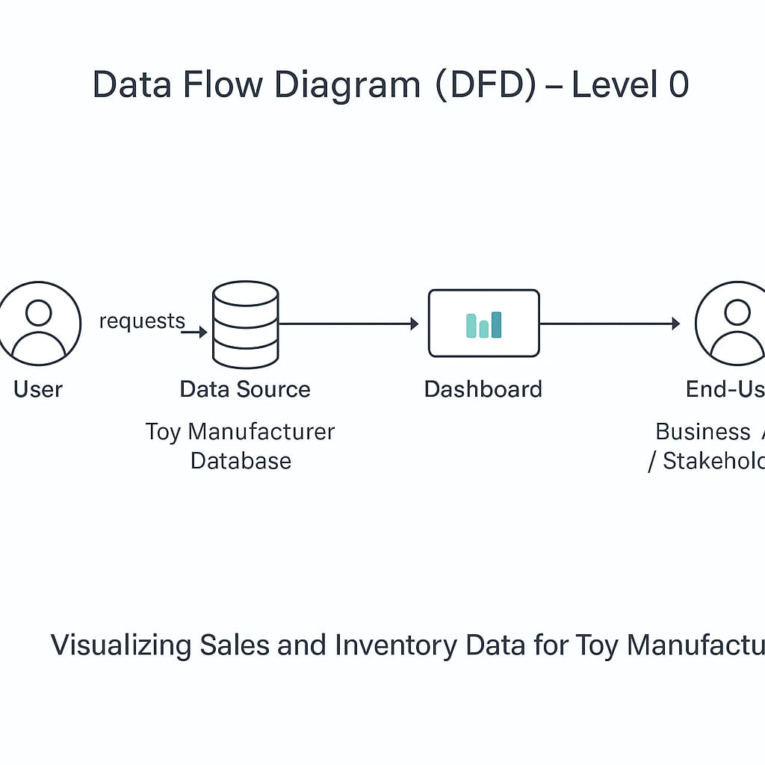

**User Stories**

|  |  |  |  |  |  |
| --- | --- | --- | --- | --- | --- |
| **User Type** | **Functional Requirement (Epic)** | **User Story Number** | **User Story / Task** | **Acceptance Criteria** | **Priority / Release** |
| Data Analyst | Data Upload | USN-1 | As a Data Analyst, I can upload Sales and Inventory data to the system | Data successfully uploaded & validated | High / Sprint-1 |
| Data Analyst | Dashboard View | USN-2 | As a Data Analyst, I can view the Sales & Inventory dashboards in Tableau | Visualizations render correctly in Tableau | High / Sprint-1 |
| Business Manager (End-User) | Report Generation | USN-3 | As a Business Manager, I can generate monthly Sales reports | Report generated accurately & downloadable | Medium / Sprint-2 |
| Business Manager (End-User) | Inventory Alerts | USN-4 | As a Business Manager, I receive low-inventory alerts | Alert triggers when stock levels fall below threshold | High / Sprint-1 |